# Create a citation in Microsoft Word

Add a citation and create a bibliography - *Applies To: Word 2016 Word 2013 Word 2007*

Before you can create a bibliography you need to have at least one citation and source in your document that will appear in your bibliography. If you don't have all of the information that you need about a source to create a complete citation, you can use a placeholder citation, and then complete the source information later.

For information about automatically formatting your bibliography in [MLA](https://www.mla.org/style), [APA](http://apastyle.org/), and [Chicago-style](http://www.chicagomanualofstyle.org/tools_citationguide.html) see: [APA, MLA, Chicago: Automatically format bibliographies](https://support.office.com/en-us/article/APA-MLA-Chicago-Automatically-format-bibliographies-733ef2c2-fb65-4641-b3e6-91b9cc92085f).

**NOTE:** Placeholder citations do not appear in the bibliography.

Add a new citation and source to a document

1. On the **References** tab, in the **Citations & Bibliography** group, click the arrow next to **Style**.

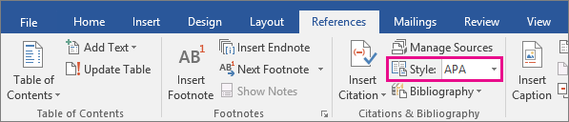

1. Click the style that you want to use for the citation and source. For example, social sciences documents usually use the MLA or APA styles for citations and sources.
2. Click at the end of the sentence or phrase that you want to cite.
3. On the **References** tab, in the **Citations & Bibliography** group, click **Insert Citation**.

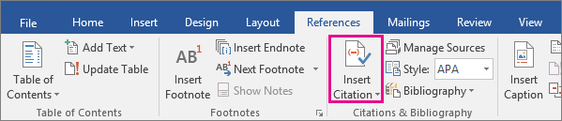

1. Do one of the following:
   * To add the source information, click **Add New Source**, then begin to fill in the source information by clicking the arrow next to **Type of source**. For example, your source might be a book, a report, or a Web site.
   * To add a placeholder, so that you can create a citation and fill in the source information later, click **Add New Placeholder**. A question mark appears next to placeholder sources in Source Manager.
2. Fill in the bibliography information for the source.

To add more information about a source, click the **Show All Bibliography Fields** check box.

Now you can create your bibliography.

**NOTES:**

* If you choose a GOST or ISO 690 style for your sources and a citation is not unique, append an alphabetic character to the year. For example, a citation would appear as [Pasteur, 1848a].
* If you choose ISO 690-Numerical Reference and your citations still don't appear consecutively, you must click the ISO 690 style again, and then press ENTER to correctly order the citations.

Create a bibliography

Now that you’ve inserted one or more citations and sources in your document you can create your bibliography.

1. Click where you want to insert a bibliography, usually at the end of the document.
2. On the **References** tab, in the **Citations & Bibliography** group, click **Bibliography**.

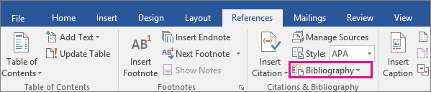

1. Click a predesigned bibliography format to insert the bibliography into the document.

## Video Link

How to Add an APA Style Bibliography in Microsoft Word (by edutechional)

<https://www.youtube.com/watch?v=yI5PppKloZw>